Phase 4 **Create Validation Rules :** Setup > Object Manager > Quote > Validation Rules > New

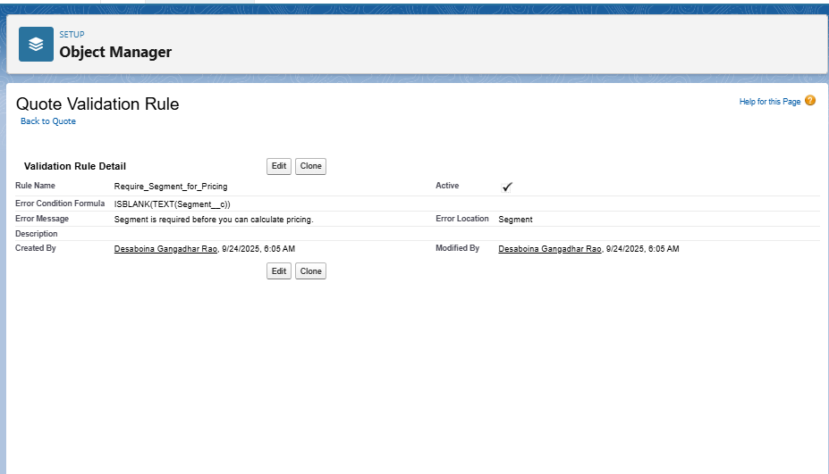

**Set Up Workflow Rules :** Setup → Quick Find → Workflow Rules → New

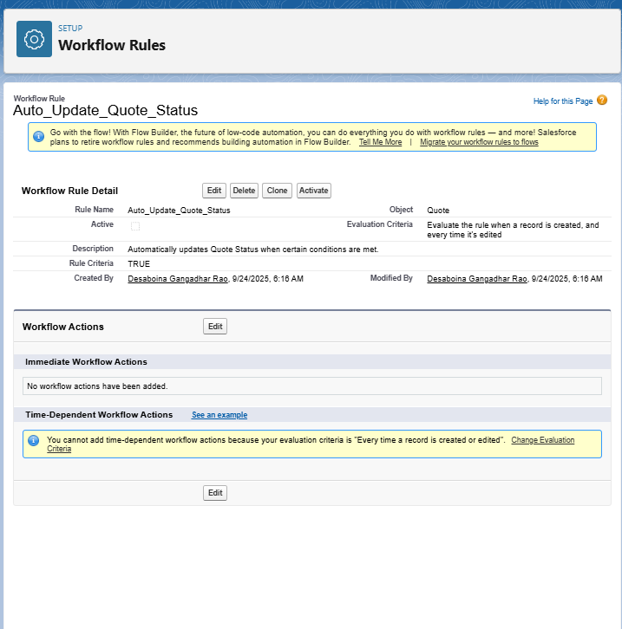

**Build Flows :** Setup → Flows → New → Record-Triggered Flow

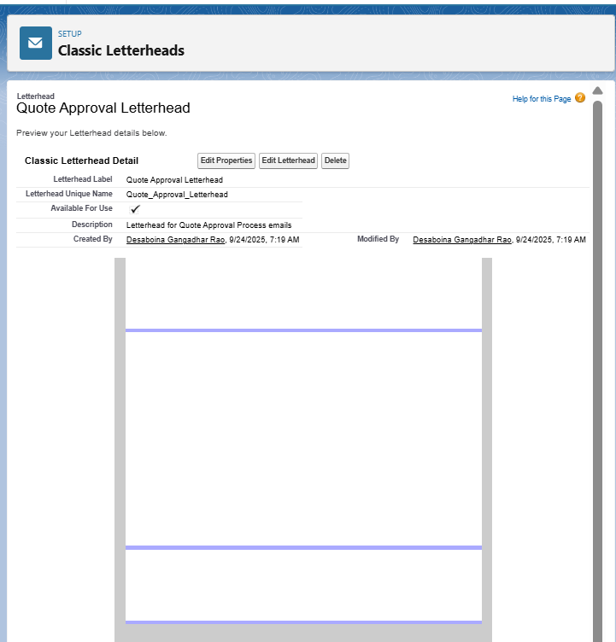

**Quote : Add products to the Quote lines it and calculated prices**

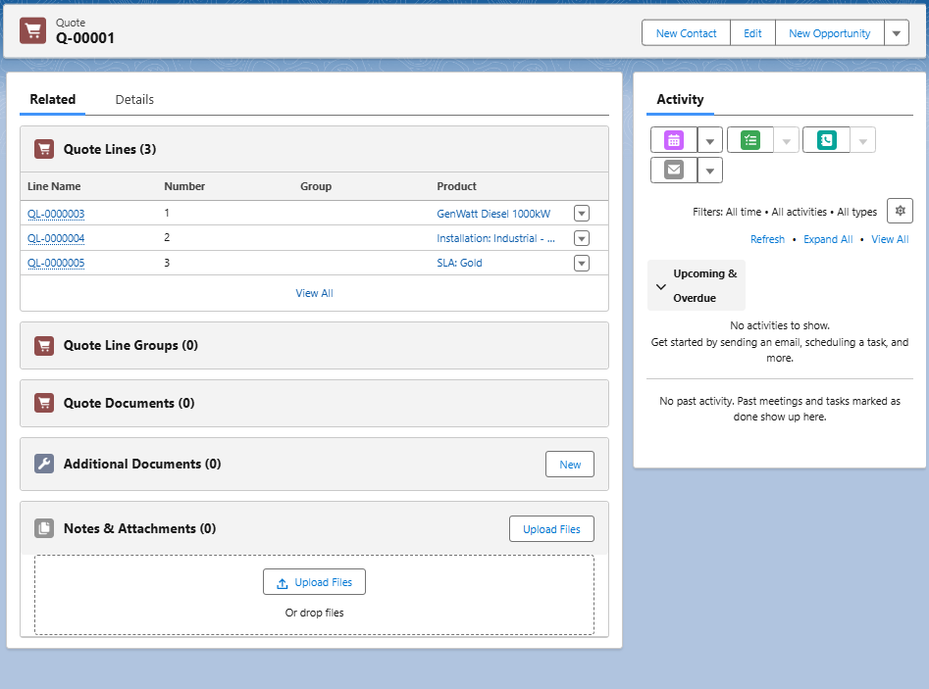

**Test/Deploy :**

**Create a new Quote**

* Go to **Quotes → New Quote**.
* Fill mandatory fields: Account, Opportunity, Segment__c, etc.
* Set **Total Customer Disc. Amount** > 1000

